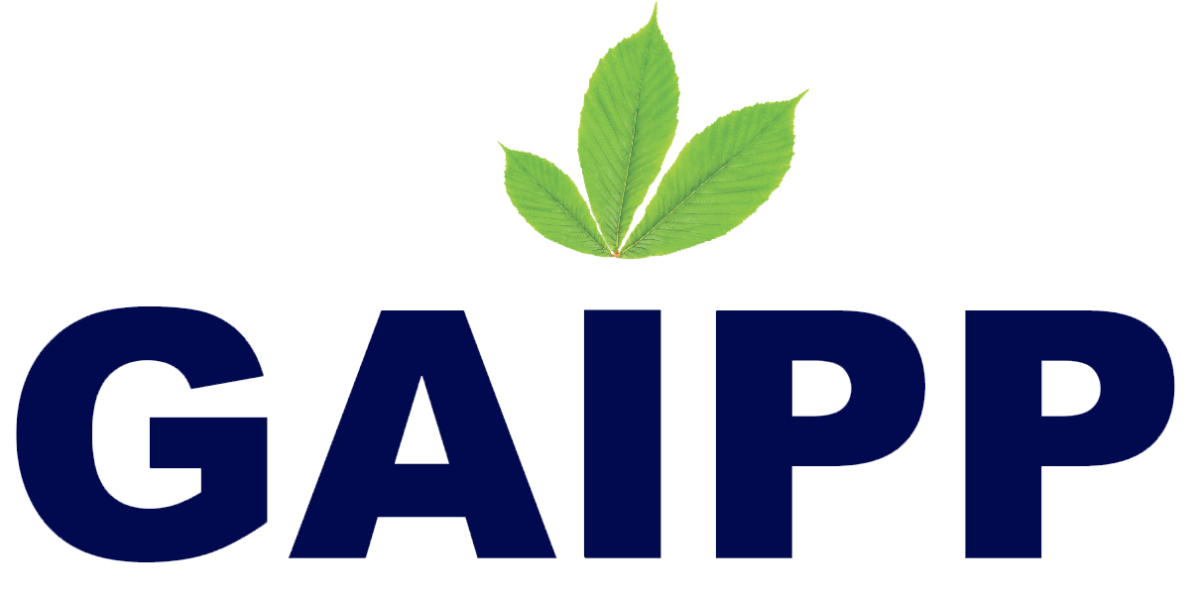

**PERSONAL & CONFIDENTIAL**

June 17th 2022

To

Mr. Sanjay Muthu

No.53, T.A.S Nagar, Chengam road,

Samuthiram eri karai, Tiruvannamalai,

Tamil Nadu,606603

On behalf of GAIPP LTD, ("the Company''), I am pleased to extend you an offer to join the company as “Content Writer”. I believe this offer provides you with a unique opportunity to further develop your professional career and to contribute significantly to the future of the Company. Based on our conversations, your start date is expected to be June 17th 2022.

Your salary will be Rs 6,000 (six thousand) per month, your paydays are expected to occur on the last day of the month unless such date falls on a weekend or a general holiday in which case you will be paid on the immediately preceding workday.

Article size should be between 600 words to 1200 words and average size is 750 words.Not more than one article must be written within two day. You will be paid 6000 rs/month of 30 days.The editorial board prefers to have 10 articles between 600 to 700 words and another 10 articles between 900-1200 words. Totally 20 articles per month. However you can schedule your number of articles as per your convenience. All writer articles will go through the editorial process, detail process and the agreement will be provided for you as a separate document.

If you accept this offer as set forth above, you must also meet the following conditions to be eligible for employment with the Company:

In addition, by accepting this offer, you confirm you are not bound by any restrictive covenant, on−competition agreement, on−solicitation agreement or other circumstance that would prevent you from accepting this position or limit your effectiveness from performing your role with the Company (as outlined herein). You agree that you either have not taken or have returned all confidential information (e.g., trade secrets, confidential business or technical information or know−how not generally known to the public) belonging to any previous employer or other third party and will not bring such information with you to the Company, nor will you use and/or disclose any such confidential information during the course and/or scope of your employment with the Company.

In case where you decide to pursue other opportunities, you agree to provide the

Company with a prior written notice of 30 days (1 months) detailing the terms.

We sincerely hope you choose to join the Company and look forward to hearing from you soon.

# RULES REGARDING OBLIGATIONS RELATED TO PREVIOUS EMPLOYERS & OTHER THIRD PARTIES

In addition to the terms and conditions outlined in your offer of employment from GAIPP Ltd, the Company expects you to adhere to the following rules to ensure you do not breach any duty to your previous employer or any other third party.

1. It is important that you return to your previous employer all company property and business information in your possession and/or control that belongs to it, including all business technical and customer account information, address lists, notebooks, training materials, company manuals, keys, credit cards, etc. If you have been using any company equipment (including a laptop or other computer, personal digital assistant and cell phone) you should not copy, download or remove any business information from it, and you should return it upon leaving your employment. In addition, if you have any other of your previous employer's business information stored on any equipment or in hard copy at a location other than your previous employer's offices or business location, you should immediately arrange for the information to be destroyed or returned to your previous employer.
2. In performing your work for the Company, you must not use or disclose any trade secrets, confidential business or technical information, or know−how not generally known to the public ("confidential information") that you learned in the course of your employment with any previous employer or third party.
3. You should not contact or solicit, directly or indirectly, any employee of your previous employer for the purpose of having the employee become employed by the Company if there is any reason that doing so would violate your previous employer's rights − for example, if you are bound by a non−solicitation agreement with your previous employer, or if in recruiting the employee you would make use of confidential information about the employee, such as his or her assignments, ranking, rating, compensation or incentives.
4. Do not make any disparaging or derogatory statements about your previous employer in the scope of your employment with the Company.

# Agreement Regarding Confidential Information and Proprietary Developments

1. This Agreement concerns trade secrets, confidential business and technical information, and know−how not generally known to the public, (hereinafter

"Confidential Information"), which is acquired or produced by me in connection with my employment by GAIPP. Confidential Information may include, without limitation, information on GAIPP organizations, staffing, finance, structure, information of employee performance, compensation of others, research and development, manufacturing and marketing, files, keys, certificates, passwords and other computer information, as well as information that GAIPP receives from others under an obligation of confidentiality. I agree

* to use such information only in the performance of GAIPP duties;
* to hold such information in confidence and trust; an
* to use all reasonable precautions to assure that such information is not disclosed to unauthorized persons or used in an unauthorized manner, both during and after my employment with Brugu.

I further agree that any organizational information or staffing information learned by me in connection with my employment by GAIPP is the Confidential Information of GAIPP, and I agree that I will not share such information with any recruiters or any other employers, either during or subsequent to my employment with GAIPP; further, I agree that I will not use, or permit use of such, as a means to recruit or solicit other GAIPP employees away from GAIPP (either for myself, or for others).

1. This Agreement also concerns inventions and discoveries (whether or not patentable), designs, works of authorship, mask works, improvements, data, processes, computer programs and software (hereinafter called "Proprietary Developments'') that are conceived or made by me alone or with others while I am employed by GAIPP and that relate to the research and development or the business of GAIPP, or that result from work performed by me for GAIPP, or that are developed, in whole or in part, using GAIPP 's equipment, supplies, facilities or trade secrets information**.** Such Proprietary Developments are the sole property of GAIPP, and I hereby assign and transfer all rights in such Proprietary Developments to Brugu. I also agree that any works of authorship created by me shall be deemed to be "Works made for Hire."

I further agree for all Proprietary Developments:

* to disclose them promptly to GAIPP;
* to sign any assignment document to formally perfect and confirm my assignment of title to GAIPP;
* to assign any right of recovery for past damages to GAIPP; and
* to execute any other documents deemed necessary by GAIPP to obtain, record and perfect patent, copyright, mask works and/or trade secret protection in all countries, in GAIPP 's name, and at GAIPP's expense.

I understand that GAIPP may delegate these rights; I agree that, if requested, my disclosure, assignment, execution and cooperation duties will be provided to the entity designated by GAIPP.

In compliance with prevailing provisions of relevant state statutes, this Agreement does not apply to an invention for which no equipment, supplies, facility, or trade secret information of the employer was used and which was developed entirely on the employee's own time, unless (a) the invention relates (i) to the business of the employer, or (ii) to the employer's actual or demonstrably anticipated research or development, or (b) the invention results from any work performed by the employee for the employer.

1. The product of all work performed by me during and within the scope of my GAIPP employment including, without limitation, any files, presentations, reports, documents, drawings, computer programs, devices and models, will be the sole property of GAIPP. I understand that GAIPP has the sole right to use, sell, license, publish or otherwise disseminate or transfer rights in such work products.
2. The provisions of this Agreement will be separately construed. If any of them is held unenforceable, the remaining provisions will not be affected.

Company Paid Vacation

You are entitled to a paid vacation of up to two (2) weeks, a total of 10 days ensuring that there will be business operational continuity in the areas of your involvement during your absence.

Sincerely,

# *Kalpana Thiru*

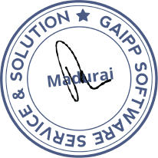

HR Manager Gaipp Pvt Ltd. hr@gaipp.io

ACCEPTED AND AGREED TO this day of June 17th, 2022

By: Sanjay, Location: Tiruvannamalai